Round Table Discussion - Technical Skills Needed to Improve Your Organization’s Environmental Data IQ

Facilitated by Dan Higgins, Dan Higgins Data Designs

ICEDM Conference Day 1, September 15, 2021

Intro: Why improving the organization’s environmental data IQ is necessary
- Christine N had a group project to aggregate data at great cost of time and money - people didn't use units and had to throw the data out.
- People creating sampling plan don't establish unique sample ids needed to work properly in a database/EDMS
- Christine L - these issues speak to people and the importance of using a team (data managers, data collectors, etc) in the loop to avoid mistakes in advance. (Kick-off meetings that include the data manager) If only meeting with programmers, they are nice, but don't know the data.

What data skills does an organization need to make its data management program successful (training, onboarding, processes, etc.)?
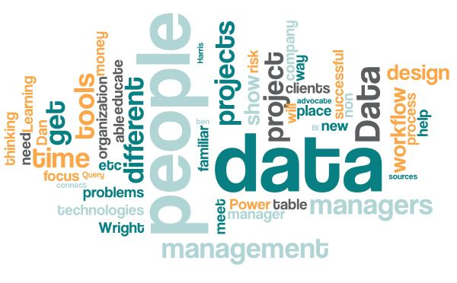
- Ben H - Power Query advocate - able to connect to different data sources (Power BI, Excel, Data Lakes…). Show the excel power users how to bring in data from EQIS in a familiar environment, then put it on SharePoint to manipulate in the MS ecosystem (PowerBI, etc.). Makes for an easy interface in a familiar application. Others in the organization will get excited about the capabilities and will adopt new data flows to perform powerful transformations
- Richard M - challenge to educate managers, manage from below to set expectations. Need more systems in place for workflow management (punch lists and requirements) before data projects get started. Use failures as teachable moments. e.g. why didn't we meet DQO standards, Why project wasn’t on time - what to do differently next time? (Dan "Learning Organization" trend to focus on learning from failure vs punishing for it. Data management budget has hidden costs because nobody knows what a realistic range should be - becomes project write-offs :(
- Lacy S - budgets aren't right for data projects. Problems become data problems, so data people need to be at the client table to clearly communicate value and cost of tools needed for successful projects. Get data people in before the beginning of projects to avoid data/knowledge silos about appropriate technologies to solve the client's problem. Data needs to be in the SOW up front for transparent processes.

How would this be implemented in an organization?
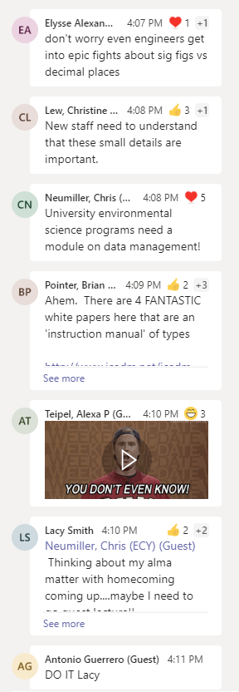
- Meghan E - Learning company. Her company is using the design thinking process to educate managers. Design process helps people come on board.
- Christine L - misperception that once tools are obtained, the money has been spent and don’t think additional investment is needed to support the workflow.
- Samantha B - focus on the workflow and meeting the goals of the project from a business analyst perspective without doing a deep dive into the technology
- Sarah W - Discussion with Brian from Panel. Data management is a huge part of risk management. People think about how not to spend money. Helped to show successes on how quick access to data = mitigated risk. Have been able to show 150% time reduction in time to accomplish tools - project manager convinced.
- Danille J - Started BD growth groups (<= 4 people) is like a monthly book club/ted talks to promote cross pollination with different disciplines. Data design thinking, communication with clients, etc. Has been successful in getting people to work together
- Sarah W - along those lines - Met with area managers - decided to invite 25 people to meet in mibo to rotate through different sections of the place with different topics in each location to help people mix and learn. Innovative way to get people to the table in an engaging way.

What data skills in technical staff, company leaders, and data managers support a data-centric culture?
- Ben - difference between different date formats - literacy about data formatting in general.
- Eliysse A - really good communication skills - how to be transparent with your team. It's okay to ask questions.
- Brian P - Data management is an interdisciplinary forum. If analytical data, need analytical chemistry knowledge - would rather train a scientist about IT than an IT person about science. Losing out on a lot of perspective if you don't have the right background.
- Morgan S - bringing things into Access and how to change date types. Knowing significant figures.
- Mark K - discussion of unique sample ids and date formats - there should be a training 101 for field techs and project managers. Is there a chapter on data management for non-data managers. Trace process from cradle to report and importance of proper data documentation is so important. It's one thing to tell someone they need sample IDs and another to train them up front on it's importance. Teaching just DM staff is preaching to the choir.
- Dan - ITRC may be working on something in this area.
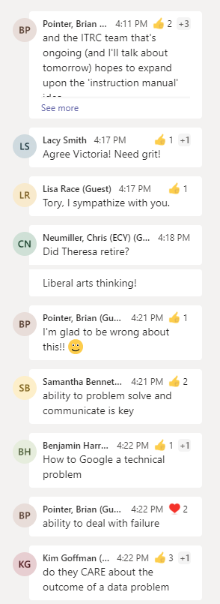
- Sarah W - started off with Microsoft Stream to host very short training videos that target certain categories. People don't read anymore, so skip the paper. Put teacher faces on videos to help make connection.
- Tony G - If there's going to be change for internal and external clients, knowledge of relational, social, team, organizational skills. Technology will keep pushing forward. Focus on question "what is the problem we are trying to solve?" graduate from hammer to power hammer to … to solve problems
- Meghan E - digital natives are coming into the workforce - know R or python, fluent with tools, but should learn the design thinking process to be more comfortable asking questions and how to ask useful questions to get information needed to give clients what they want. ERM is starting to offer design thinking training and it is turning out to be a very useful skill.
- Lisa R - Client PMs want an EDD and will send a picture but can't answer clarifying questions about specs and don't know who to ask. Just wants "EDD to put in database". Need training to know what you're asking for and be able to pass along this knowledge.
- Victoria W - another helpful skill would be patience for troubleshooting and how to fix what's wrong. Some people tend to walk away when they get frustrated.
- Sarah W - another question goes into how to hire. Has been discussed in previous ICEDMs. ERM is hiring like crazy right now. Have had great success hiring people. Have had good luck with this. Were looking for entry level folks - not the typical background - econ and international studies - turned out to be a wonderful hire. Medical lab background - turned out to be great with info. Don't count people out just because they don't fit your mold. Cautionary tale - some people use software differently, so just because they know an application doesn't mean they will use it the way you want them to. Ask tough questions. How to troubleshoot, how to google tough problems. Make sure you hire nice people!!!
- Morgan S - chime in about new hire without data experience, and she's amazing. She's a hard worker, good person, communicates well, cares, and willing to learn. Wants to do a good job.
- Kristen B - recent hiring process. Looked for certain skills on resume and these folks were most likely to leave. It's more about attitude and desire to learn. Ability to communicate and recognize when people try/don't try to solve problems and/or won't reach out when they have questions. Environmental policy and likes to play with excel = good hire.
- Samantha B - aligns hiring process with core values. Always taking the high road, united and caring.
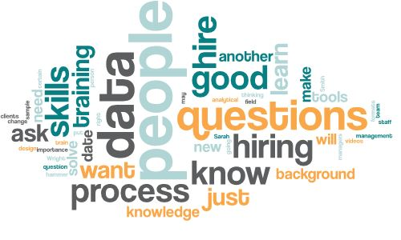
- Rich M - it's not always about tech skills. Want to know if people are willing to be part of an organization and adapt to improve organization. May be adept at applications but wasn't going "with the program". Used a nifty tool that was incompatible with security requirements. People who are unwilling or unable to see how desktop tools become enterprise tools.

